**Behaviour Policy**



**March 18**

**Approved by Governing Body – March 2018**

**Review Date: March 2021**

**Chisenhale Primary School**

**Behaviour Policy**

**Policy**

We recognise the importance of a positive approach to behaviour in school. The purpose of this policy is to give clear guidance for the use of all at Chisenhale, both adults and children. The policy has been written after discussion with staff, children and governors. It reflects the values and principles we consider to be important for the school; in particular those laid down in the United Nations Convention on the Rights of the Child. This policy should not be seen as something static, but must be responsive to changes within the school.

**Aims and Ethos**

In Chisenhale we accept the principle that good behaviour is a necessary condition foreffective teaching and learning to take placeand so we seek to create an environment within the school which encourages and reinforces good behaviour.

We believe that children will strive to reach high standards of behaviour and therefore we endeavour to maintain high expectations through a consistent and positive behaviour management policy. We wish to ensure a happy and caring community, which encourages respect for others’ feelings, beliefs and possessions within a stable and caring environment. We understand that such a community needs a structure to support acceptable and agreed forms of behaviour.

In Chisenhale we aim to implement a positive behaviour management system in which all adults within the school consistently model the desired standard of behaviour. We expect children to take responsibility for their own behaviour and so give them every opportunity to be involved in its management. We encourage children to consider their rights and the rights of others and help them to understand that with these rights come responsibilities.

In developing our policy we have drawn heavily on the researched based approaches of emotion coaching and restorative practise.

Through our policy we aim:

To enable pupils:

* To feel safe and secure
* To develop an understanding of the different emotions they experience, why they occur and how to handle them
* To develop responsibility for their own behaviour
* To understand that these responsibilities are derived from respecting the rights of others
* To encourage and foster positive attitudes
* To develop a co-operative approach
* To develop an understanding of the need for responsible behaviour (safety, thoughtfulness etc.)
* To develop an effective range of strategies for dealing with problems, including restorative conversations.

To enable adults:

* To consistently model high standards of behaviour
* To demonstrate empathy towards others, even when their behaviour is challenging
* To provide a caring and effective learning environment.
* To encourage relationships based on kindness, respect and understanding of the needs of others.
* To use an emotion coaching approach, whenever possible, when dealing with pupils’ behavioural difficulties
* To follow an agreed format of rewards and consequences
* To support each other with the agreed format
* To provide children with a consistent framework of expectations in their whole career at our school
* To ensure that opportunities and/or training are given to the children so that they can become more responsible for their own behaviour e.g. Emotion Coaching, Restorative Practise, Circle Time, PSHE.
* To ensure fair treatment for all regardless of age, gender, race, ability and disability.

**The Curriculum and Learning**

We believe that an appropriately exciting and challenging curriculum contributes to good behaviour and effective learning. As a result, we have developed a creative curriculum which includes regular opportunities for cross-curricular work and which aims to provide pupils with opportunities to work both individually and cooperatively and encourages them to become independent, self-motivated learners. We recognise that making mistakes is integral to effective learning and encourage pupils to view mistakes as positive learning experiences. We aim to support our pupils in developing growth mindsets.

Through the PSHCE curriculum children are supported in developing a solid understanding of relationships with other people, how we should treat one another and the cause and effect of our actions. The curriculum also empowers the children with emotional literacy to help them express how they are feeling.  Anti-bullying is taught as a set topic every year where children use role play and experiences to embed their understanding.  The language of choice runs through the whole curriculum, encouraging the children to know that there are consequences (be it positive or negative) to every action they take. We are introducing a ‘Restorative Practice’ and Emotion Coaching approach in order to provide a consistent framework for further engaging children in managing their own behaviour.

Pupils’ views are sought on a regular basis through the School Council.

**Classroom Management**

At Chisenhale we accept that classroom management and teaching methods have an important influence on children's behaviour. The classroom environment gives clear messages to the children about the extent to which they and their efforts are valued. Relationships between adults and children, strategies for encouraging good behaviour, arrangements of furniture, access to resources and classroom displays all have a bearing on the way children behave.

We aim for classrooms to be organised in such a way as to develop independence and personal initiative. Furniture is arranged to provide an environment conducive to on-task behaviour. Materials and resources are arranged to aid accessibility and reduce uncertainty and disruption. High quality displays are used as a means of engaging pupils and in developing self-esteem through demonstrating the value of every individual's contribution.

We try to ensure that our teaching methods encourage enthusiasm and active participation for all. For example, we regularly use talk partners to ensure that all pupils participate in class discussions and we provide regular opportunities for collaborative open-ended investigations in maths. In our lessons we aim to develop the skills, knowledge and understanding that will enable the children to work and play in co-operation with others.

**Procedures**

There are agreed procedures, which are used across the school, which have been widely consulted with all stakeholders and which are regularly reviewed. These are all underpinned by our philosophy of consistent, positive behaviour management.

We are a Level 1 UNICEF Rights Respecting School and are working towards our Level 2 award. Each class writes their own class charter at the beginning of the school year. The charter is created by the children. They select the rights that they think are most important. The children then agree what children and what adults need to do in order to enable these rights. All adults use, and encourage children to use, rights respecting language when discussing issues around behaviour. For example, if a child was disrupting the learning of other children an adult might say ‘We all have the right to learn in this class. You are preventing the other children having their right to learn at the moment so you need to stop calling out’.

In addition each class has Rights Rocket and on it each child has their name on a label. Surrounding the rocket are planets. All children start each day on the Rights Rocket and can be moved to the planets or have their name written in the teacher’s Behaviour Book depending on their behaviour. (See pages 7-9 for further details.)

**Misbehaviour**

We recognise that there will be occasions when there will be problems. We believe that we should always try to understand the reasons for misbehaviour, so that we can deal with it most effectively. When dealing with problems, it is important always to label the behaviour and not the child. We recognise the importance of a consistent approach across the school. In speaking to pupils about their behaviour it is always better to remind them of the behaviours we expect of them rather than to dwell on what they have done wrong. As far as possible, we aim to use an emotion coaching approach (See Appendix 3) in helping children to think about their behaviour.

We are aware of our responsibility for pupil well-being. As part of our approach to behaviour which does not live up to school expectations and which disturbs, disrupt, offends or otherwise negatively affects pupils and staff, we will initially respond to incidents of misbehaviour as outlined in this policy, which aim to check that behaviour and its interference with learning and a positive environment. However, we recognise that such behaviour may be as a result of a difficulty with emotional regulation and, where this is the case, we will support the child in their emotional development. We also recognise that poor behaviour in school may be an indication of well-being/ child protection concerns and where we determine this to be the case we will also deal with the situation through our safeguarding procedures

**Additional Support**

We recognise that, from time to time, many of our pupils may struggle socially, emotionally or behaviourally. We have a rage of support in place for these pupils. All of our staff have received training in emotion coaching and restorative practises. We have a full time Learning Mentor. We buy into a project called Motivate2Educate, who provide support for up to five pupils and their families at a time. In addition two members of support staff are currently being trained to become Emotional Literacy Support Assistants (ELSAs). Two members of staff are also trained in the ‘Drawing and Talking’ intervention. In addition to pupils receiving individual support we regularly run group interventions such as social skills groups and Lego Therapy groups.

**Class Behaviour Chart**

Each class has a Behaviour Chart displayed in in the class room. The chart is centred around the Chisenhale ethos ‘Learning Together for a Better Future’ and encompasses the Unicef Rights:

28. You have the right to a good quality education

29. This education should help you to learn to live peacefully, protect the environment and respect other people.

19. You have the right to be protected from harm.

The chart is made up of the following:

A Rights Rocket

6 Planets representing:

* Kindness
* Deep thinking
* Respect
* Cooperation
* Independence
* Resilience

Plus:

* an extra planet for when a pupil shows a special quality not covered by the other six.

All children will have a label with their name on it and at the start of each day all names are on the Rights Rocket.

When a child makes a positive choice with their work or their behaviour then their name is moved onto a planet. A dojo point is then awarded to the whole class (encouraging team work and collaboration). The child may also be given the opportunity to share their success with a member of the SLT or phase leader, or be given praise/comments in their book. Other children in the class can make a ‘shout out’ for a child to be moved to a planet, if they think the child has done really well in something.

If children make inappropriate choices then they are quietly reminded of the expected positive behaviour/action. E.g. ‘You are stopping other children from having their right to an education by continually calling out. You need put your hand up and wait your turn.’

‘Your behaviour is dangerous and you are stopping other children having their right to play. You need to calm down and listen to adults.’

Children will get at least two reminders. However should the behaviour continue, their names will be recorded in the teacher’s book on the desk. Children are then given the opportunity to change their behaviour and have their name crossed from the book. E.g.: ‘You need to have completed 3 more questions/ the next paragraph etc. when I come back to check so that your name can be crossed off.’

Should the child’s name remain in the book at the end of the session, the adult who has been dealing with the behaviour will spend time discussing this during playtime or lunchtime for a short period with the child. The adult will use an emotion coaching approach. If a child has not completed their work by the end of the session they may be asked to stay back to complete it.

Serious incidents occasionally occur in school these will lead to the child spending time with a member of the SLT. If a child refuses to go where they have been asked, the teacher will send another adult or child with an ‘SLT Needed’ card to the office. Serious incidents can lead to the child missing up to 15 minutes of their Golden Time. This can also be the outcome if a child is persistently getting their name recorded in the behaviour book.

The Parents or Carers are informed of serious incidents and of repeated low level incidents.

The most serious incidents can lead to internal exclusion or fixed term exclusion.

Incidents between Children

Where there are incidents between children (arguments, name-calling, fighting etc.) the children will be brought together by an appropriate adult and supported to engage in a restorative conversation. The conversation should follow the agreed format:

1. Telling the story (the what and the why)
2. Exploring the harm (this could be physical harm or harm to feelings)
3. Acknowledgement (and apology)
4. Developing a plan including follow-up
5. Close

We understand that there may be barriers to participation in this type of conversation, such as pupils’ communication, cognition or behavioural difficulties. We aim to ensure that the process is appropriately adapted for these children. For example, where children have language and communication difficulties we will ensure they have access to appropriate visuals to enable them to tell their story

Pupils with significant social, emotional or mental health difficulties

We acknowledge that for some pupils, particularly those with social, emotional or mental health difficulties (SEMHD) this general approach may not work and in those cases we may need to develop Individual Behaviour Plans/ Pastoral Support Plans/ Green Zone Plans, in consultation with parents and with appropriate outside agencies, where necessary.

**Rewards**

Although our ultimate aim is for children to be self-motivated, we believe that rewards can have a motivational role, helping children to see that good behaviour is valued. The most common reward is praise, informal and formal, public and private, to individuals and groups. It is earned by the maintenance of good standards of behaviour, by showing empathy and kindness to others, as well as by particularly noteworthy achievements. A particular emphasis is put on praising pupils who persist with a learning task, despite finding it tricky, pupils who select a more challenging activity when offered a choice and pupils who are seen to put real effort into trying to manage their behaviour, even when this is really difficult for them. Staff are encouraged to make many more positive than negative comments to children and we try to ensure that good behaviour is praised equally as much as good work. We also try to ensure that our praise is given in such a way as to ensure that pupils are very clear on exactly the behaviour that is being encouraged and that pupils are usefully and appropriately rewarded for their achievement.

In addition to praise we also use a range of other rewards. Among those used at present are:

* comments in children’s books
* public praise, in front of peers
* lunchtime stickers
* showing good work to another teacher or member of SLT
* name in the Golden Book for celebrations assemblies on Fridays
* sharing achievements with parents both verbally or through postcards home, which are sent when children are in the Golden Book for work or behaviour
* Dojo Points
* Class/ Phase Treat (At the start of each year a target number of Dojo points is agreed and the children decide on a list of possible treats. It is decided in Phases whether the treat will be a Phase or a Class treat. Once the target has been achieved, the children vote on their preferred treat, from the agreed list. The process then starts again.)

Friday Golden Clubs

We assume that the children will behave according to the school expectations and Class Charters at all times and therefore the children automatically receive their reward for good behaviour. Their reward is Friday Golden Clubs each week. These are an exciting enrichment opportunity for the children. In addition to taking part in Golden Clubs children are also encouraged to run clubs, with support from staff

Completing Work

From time to time pupils may be required to complete work during playtime or lunchtime if it felt that they were not applying themselves sufficiently during lesson time.

Behaviour in the playground and at lunchtime

Playtime should be a safe and enjoyable time for all children in the school. It is essential that all staff on duty are actively engaged in supporting children in playing successfully and in monitoring behaviour. All staff should be noticing and praising good behaviour and addressing poor behaviour appropriately.

* When children are seen to be behaving particularly well in the playground e.g. being kind, sharing, including others in their games, not responding to provocation etc, then they are given stickers, which can be converted into Dojo points when they go back to class.
* When children are observed to be becoming overly exuberant / wound up in the playground staff should encourage these pupils to take some calming time-out/ take some deep breaths/ get a drink in order to calm down etc.
* As in class children who are seen to not be doing the right thing should be encouraged to change their behaviour in the first instance and be warned of the consequences of persisting with inappropriate behaviour.
* When talking to children about their behaviour adults should use the ‘Restorative Chat’ prompt cards.
* Where a child’s behaviour is posing a risk to themselves or to other children and they are not responding to the adults in the playground, other children should be directed to move away and a child sent into the office with an ‘SLT needed’ card.
* Children who persist with poor behaviours have their behaviours recorded on CPOMS by the staff on duty at playtime or by the Senior Mid-day Staff at lunchtime.
* Children who regularly show poor behaviours may miss playtimes during the week and or/ be spoken to by SLT.
* Fighting on the playground results in 2 days missed playtimes.

**Bullying, racist and homo-phobic name calling**

Bullying needs to be tackled immediately – please see the Chisenhale anti-Bullying Policy for our definition and actions that need to be taken.

All racist and homophobic incidents need to be logged as soon as possible on CPOMS.

**Recording and Monitoring**

Incidents should be recorded by the adult who observes/ initially deals with the incident on CPOMS. Relevant staff should be alerted via CPOMS at this time. (The Head and Assistant Head responsible for inclusion will receive notifications of all incidents.)

Follow up action will also be recorded on CPOMS by the relevant member of staff. This may be the class teacher, Phase Leader or other member of the SLT.

The Assistant Head responsible for inclusion will be responsible for overall monitoring of incidents throughout the school.

The teacher will make a note in their book of the name of a child who, despite at least two reminders, has continued to make poor choices. The name can be crossed out if the child then starts working well/ stops disrupting other’s learning etc. If the child’s name remains in the book for 3 sessions in a week they need to see the Phase Leader for reflection time, the Phase Leader will record this on CPOMS.

All serious incidents need to be recorded on CPOMS.

**Communication and Parental Partnership**

We give high priority to clear communication within the school and to a positive partnership with parents since these are crucial in promoting and maintaining high standards of behaviour.

Where the behaviour of a child is giving cause for concern it is important that all those working with the child in school are aware of those concerns, and of the steps which are being taken in response. The key professional in this process of communication is the home class teacher who has the initial responsibility for the child's welfare. Early warning of concerns should be communicated to the Phase Leader or the Assistant Head so that strategies can be discussed and agreed before more formal steps are required.

A positive partnership with parents is crucial to building trust and developing a common approach to behaviour expectations and strategies for dealing with problems. Parental participation in many aspects of school life is encouraged. This participation assists the development of positive relationships in which parents are more likely to be responsive if the school requires their support in dealing with difficult issues of unacceptable behaviour.

The school will communicate policy and expectations to parents. Where behaviour is causing concern parents will be informed at an early stage, and given an opportunity to discuss the situation. Parental support will be sought in devising a plan of action within this policy, and further disciplinary action will be discussed with the parents.

The school runs a yearly 13 week Strengthening Families, Strengthening Communities course where parents can get support and advice on managing their child’s/ children’s behaviour. We also run regular ‘Early Words Together’ courses, supporting parents in the EYFS in developing high quality interactions with their children and improving their communication skills.

**Dealing with Significantly Challenging Behaviour**

The health and safety of staff and pupils is paramount at Chisenhale. All challenging behaviours can be a potential risk to staff and other pupils in the classroom or other environments and should therefore be regarded seriously.

Any pupil who has significantly challenging behaviour could be a potential risk to staff or other pupils and MUST have a Behaviour Support Plan (BSP) or Green Zone Plan. By challenging behaviour, in this context, we mean behaviour which is likely to:

1. cause physical harm to either the pupil themselves or others
2. regularly cause serious disruption to the education of other pupils
3. damage school property

Some behaviours are predictable and happen regularly. Other behaviours may be infrequent and totally unpredictable. After these behaviours have happened once, and it is judged that they are likely to reoccur, they must then be planned for.

It is the class teacher’s responsibility to consider the behaviours of the pupils in the class and liaise with support staff and other relevant staff when writing a BSP or a Green Zone Plan. Once a pupil has been identified by the class teacher as being in need of a BSP or Green Zone Plan, the teacher should seek advice and support from the Phase Leader and/ or the Assistant Head in writing it. A meeting then needs to take place with the pupil and the parents/ carers in order for them to contribute to and agree the plan. A member of the Senior Leadership Team should also attend the meeting.

It is the class teacher’s responsibility to review BSPs/ Green Zone Plans regularly and update with any new information and to ensure that all staff working with the pupil are informed of the behaviours that may occur. Once completed BSPs should be saved on the shared drive, in the Behaviour folder. It is the responsibility of other staff working with the pupil to make themselves familiar with his/ her BSP. Green Zone Plans should be saved in the SEN folder on the shared drive.

(Note: Pro formas for BSPs and Green Zone Plans can be found in Appendix 6 and are available in the behaviour folder on the shared area.)

In the event of an incident occurring there is a procedure that must be followed at all times.

See Appendix 5 for details of Physical Intervention Procedure - For forms needed to carry out these procedures please see shared drive – read and write – behaviour.

Appendix 1

**Principles of Restorative Practice**

1. Restoration (Acknowledge harm. Enable all parties to move on.)
2. Voluntarism (Both sides need to want to engage in the process.)
3. Neutrality (Adult does not take sides. On both sides.)
4. Safety (Victim – process could re-traumatise.)
5. Accessibility (Children understand process and can make sense of what they are being asked to do.)
6. Respect (Both parties.)

**Restorative Chat Prompt Card (EYFS & KS1)**

* Let’s stop and use our words.
* Tell me what happened / I’ll tell you what I saw.
* So you felt… / I wonder if you felt…. (to both children)
* How can we can fix this? (should we shake hands / have a hug / say sorry / play together with the…)
* So next time you need to….. (ask her for a turn / use a sand timer / choose something else)

**Restorative Chat Prompt Card (KS1 & KS2)**

* Tell me what happened
* What were you thinking at the time?
* What do you think about it now?
* Who has been affected? How have you been affected?
* What’s needed to make things right?
* How can we make sure this doesn’t happen again?

**Appendix 2 - Restorative Chat - Tell me what happened?**

When did it happen?

[](http://www.google.co.uk/url?sa=i&rct=j&q=&esrc=s&source=images&cd=&cad=rja&uact=8&ved=0ahUKEwi474-X_sDMAhUG6RQKHX4bA2wQjRwIBw&url=http://www.magnifyingaids.com/Clocks&psig=AFQjCNHnLiZGSPgX7dJjysYRh7JSNrDK8Q&ust=1462470708005241)

Who was there?

[](http://www.google.co.uk/url?sa=i&rct=j&q=&esrc=s&source=images&cd=&cad=rja&uact=8&ved=0ahUKEwi15Z73_cDMAhUHVBQKHZ-oASkQjRwIBw&url=http://www.mobilebeat.com/its-people/&bvm=bv.121099550,d.d24&psig=AFQjCNHUMMJwH7Sgu_R9a0hXL_dA87s09Q&ust=1462470658400689)

Where did it happen?

[](http://www.google.co.uk/url?sa=i&rct=j&q=&esrc=s&source=images&cd=&cad=rja&uact=8&ved=0ahUKEwiC3qC6_cDMAhVH7xQKHTtkDJEQjRwIBw&url=http://lifehacker.com/top-10-ways-to-find-the-best-place-to-live-1634031154&psig=AFQjCNHUvTYA0ajG_DA8RFDIz5lz1adawg&ust=1462470533769267)

What did you think/feel?

What did they think/feel?

What did the other person/people do?

[](http://www.google.co.uk/url?sa=i&rct=j&q=&esrc=s&source=images&cd=&cad=rja&uact=8&ved=0ahUKEwjS3Kz-_sDMAhWEOxoKHbgYADIQjRwIBw&url=http://blog.psoda.com/who-needs-an-action-register-anyway/&bvm=bv.121099550,d.d24&psig=AFQjCNFiasZ974XtL7qMIQthJT8uBz_tng&ust=1462470925585226)

First?

Next?

Next?

What did you do? [](http://www.google.co.uk/url?sa=i&rct=j&q=&esrc=s&source=images&cd=&cad=rja&uact=8&ved=0ahUKEwjS3Kz-_sDMAhWEOxoKHbgYADIQjRwIBw&url=http://blog.psoda.com/who-needs-an-action-register-anyway/&bvm=bv.121099550,d.d24&psig=AFQjCNFiasZ974XtL7qMIQthJT8uBz_tng&ust=1462470925585226)

First?

Next?

Next?

What happened in the end? ( for you / for the other person)

What is needed to make things right?

[](http://www.google.co.uk/url?sa=i&rct=j&q=&esrc=s&source=images&cd=&cad=rja&uact=8&ved=0ahUKEwiDs4u2_sDMAhXBuhQKHdO5CZwQjRwIBw&url=http://www.freepik.com/free-icon/thumbs-up-hand-symbol_744198.htm&bvm=bv.121099550,d.d24&psig=AFQjCNHenLuR461MWLE78UZKVm4a8GlMHQ&ust=1462470790456985)

What are other people thinking/feeling now?

What are you thinking/feeling now?

What could you do next time?

What could you do next time?

**Appendix 3 - Emotion Coaching Steps**

**Connection before Correction**

Emotion coaching requires that all the adults are willing and able to build a trusting, respectful relationship with children.

Trusting others is often something which vulnerable and traumatised people find difficult, making it particularly hard for them to initiate and maintain positive relationships. They will erect protective barriers and it is up to adults to demonstrate that they are trustworthy and treat children respectfully. This emotional engagement can feel risky for adults but is necessary if the child is going to be able to co-regulate.

The phrase ‘connection before correction’ (Golding et al 2012) is a powerful way to remind yourself of the importance of making the empathetic connection as a first step.

**Step 1: Empathise, validate and label**

What will the adult be doing?

* Recognise all emotions as being natural and normal and not a matter of choice
* Becoming aware of the child’s emotional state and recognising the opportunity for co-learning
* Accepting the emotions and finding words to name the feelings
* Recognising behaviour as communication- relational versus behavioural model
* Looking out for physical and verbal signs of the emotion being felt
* Taking on the child’s perspective (attunement, mentalising, mindfulness)
* Using words to reflect back the child or young person’s emotions and helping them to label the emotion
* Affirming and empathising, allowing the child to calm down through co-regulation. Co-regulation allows the child to mirror the respect given to them by the adult – emotional mirroring is more powerful even than the fear of emotional engagement felt by vulnerable children
* Providing a narrative for the emotional experience, creating cognitive links through co-learning with the child and then teaching

It can be appropriate to suggest moving the conversation to a different space if that is possible. A soothing environment where the child feels safe can help with co-regulation. Knowing when the child is able to accept this suggestion is a matter of your knowledge of and your relationship with the child.

What might the adult say?

*“I can see that you get angry when that happens. I would feel angry if that happened to me. It’s normal to feel like that.”*

*“I can see you’re frowning and you’re kicking the wall and expressing a lot of energy. I would be feeling like that too if I didn’t want to do something.”*

*“I noticed you looking around at the others who are working on their projects. I think you might be feeling nervous about whether your work will be OK. Have I got that right?”*

**Step 2: Rapport before Reasoning – Setting Limits**

Establishing that there are clear limits about what behaviour can be allowed to continue is a critical second step in the emotion coaching process.

What will the adult be doing?

First – co-regulation, establishing rapport by:

* Building on attunement with the child
* Creating engagement with the social and emotional brain: mirror neurons
* Acting empathetically to set the emotional tone
* It is important that the adult is not reflecting back the angry or distressed face of the child, so that the child is able to reflect back the calm and empathetic face of the adult

Then – co-learning, discovering what the child needs in order to move forward:

* Co-learning informs teaching
* Separating the emotion which is acceptable from the behaviour which may well be unacceptable
* Stating the boundary limits for what is acceptable behaviour
* Making it clear that some behaviours cannot be accepted

There may well be concerns about what happens if the shift in focus is talking about the child’s behaviour causes the child to ‘lose it’ and flare up again. This is certainly a point to consider and it will probably happen sometimes! Returning to the previous step, and re-establishing the empathetic connection to co-learn what the child needs, may well be necessary.

It is also helpful to know that you are not working in isolation. Training all staff in a setting about emotion coaching reduces the risk that individuals will lose confidence and revert to previous disciplinary styles.

What might the adults say?

“*These are the rules we have to follow in the swimming pool. Doing that is not OK.”*

*“We can’t behave like that even though you are feeling annoyed, because it is not safe.”*

*“You didn’t do the task as we agreed. You’re probably angry that you can’t join in with the practical session with the others now because you have to complete the written assignment first.”*

**Step 3: Problem Solving with the Child**

When the child is calm and in a relaxed and rational state

What will the adult be doing?

Exploring the feelings that gave rise to the behaviour, problem or incident

* Remembering that all feelings are acceptable
* We manage our feelings by making choices about how we respond
* Encouraging alternative ideas and actions that could build on the positives and lead to more appropriate and productive outcomes. Remember that the adult will need to adapt the level of problem solving according to the developmental level of the child, enabling them to build on experience.
* Empowering the child to believe they can overcome difficulties and manage their own feelings and behaviour.

What might the adult say?

*“This is not a safe place to be angry. Let’s go find a safe place and then we can talk.”*

*“Next time you’re feeling like this what could you do? How do you think you will react if this happens again?” ”You need to work in a group with Ruth or work with me – which do you want to do?”*

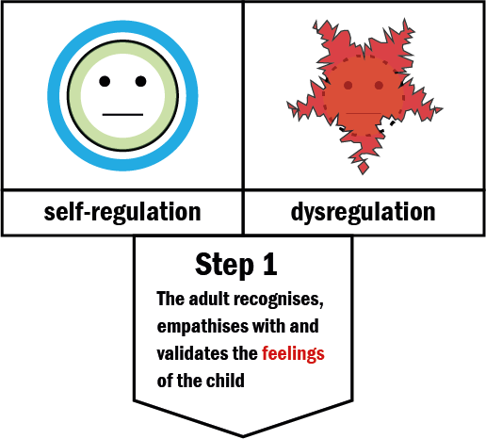

Enables the adult to maintain their own self-regulation while attuning to the child. The psychological changes in the dysregulating child are safely mirrored in the body of the mindful adult.

**mindfulness**

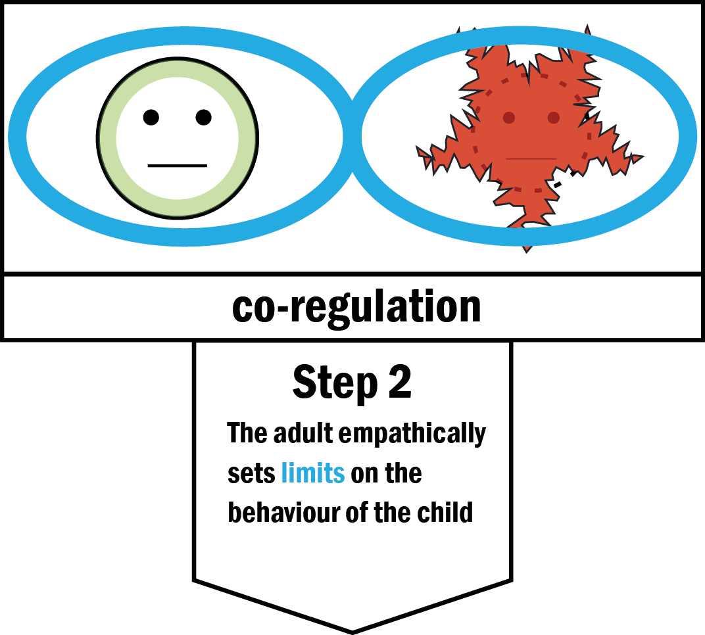

Enables the child to benefit from the adult ability to self-regulate. The brain as a social organ mirrors the activity of the vagus nerve in the adult which calms the arousal of the nervous system.

**co-regulation**

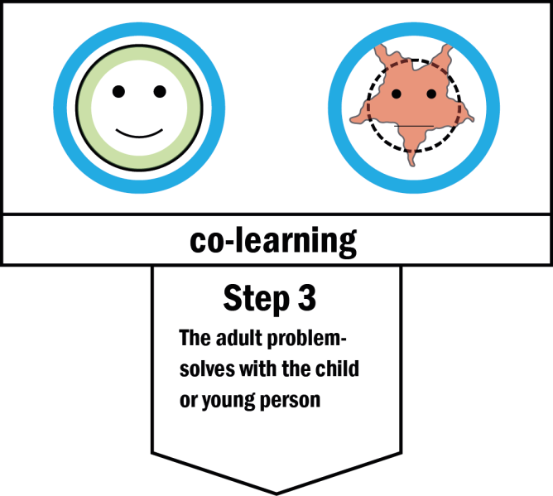

Enables the child to learn from the adult because the adult has demonstrated that they have been learning from the child. Attunement and mirroring create trust which promotes learning.

**co-learning**

**When these processes have been effective, they result in the child being able to self-regulate like the adult**

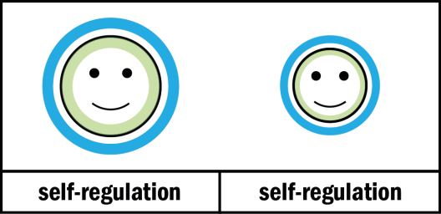

Appendix 4 **Response to Behaviours**

|  |  |
| --- | --- |
| **Low Level Behaviours** (taking into account the needs of different children)  *those which may affect the flow of the lesson but do not impinge on others’ rights to learn and feel safe and valued* | **Positive Responses**  *Getting the pupil back on task without additional input from staff or consequences for pupil… and preventing an escalation of behaviour* |
| * banging chairs * chair rocking * unruly lining up * unruly walking around school as a class group * rolling around on the floor * getting up and moving * wandering around * not moving sensibly in class – pushing, sliding onto the carpet * reluctance to finish work * refusal to come and sit down * not responding to cues and signals e.g. bell * ‘selective’ hearing * not listening * repeating behaviour after being asked to stop * writing whilst teacher is talking * turning around and not looking at the speaker * talking across the table/ room * funny background noises –whistling, humming * laughing inappropriately * talking whilst the teacher is explaining the work * arguing/ answering back * calling out * whispering/ muttering * pencil/ pen tapping * not taking notice of each other – e.g. sitting on top of each other, squeezing between children, pushing in line * not treating classroom equipment correctly * annoying/ touching/ poking other children (first time) * flicking/ throwing paper/ objects * fiddling with pens * manners * fussing with shoes and laces | * **directing pupil to wanted behaviour** – ‘I’d like to see you sitting quietly’ (using the ‘broken record’ approach to avoid being drawn into discussion with the pupil) * **take-up time** – giving the pupil time and space to follow an instruction as though they are trusted to comply * **proximity** – moving close to pupil misbehaving * **praise –** of pupils ‘doing the right thing’ * **catching pupil’s eye** and miming desired behaviour * **pointing out the behaviour/ context** – and allowing the pupil to self-correct – ‘You are calling out/ we’re doing quiet reading’ (+broken record) .. follow-up with a prompt such as ‘What should you be doing ?’ * **tactical ignoring –** good for managing attention seeking behaviours (time limit + follow up strategy) * **choice + consequence –** ‘If you continue to choose to talk whilst I am explaining, I will have to move you down a colour.’ * **adding ‘thanks’** to an instruction, to show that you are expecting compliance: ‘Could you just pick up that pencil? Thanks!’ * **rule reminders –** ‘In this class we put up our hands if we have something we want to say. Thanks!’ * **modelling** the desired behaviour – e.g. talking quietly to set the tone. * **partial agreement –** (for avoiding argument/ discussion over behaviour) – ‘You may think that it’s unfair, but we’re lining up now.’ * **‘when…then’ –** following what you want with what the pupil wants – ‘When you have picked up the pencils then you’ll be ready to go.’ * **pause…direction –** make eye-contact with the pupil and give them a moment to self-correct before issuing a direction * **mention the pupil by name** * **distraction and diversion –** good for avoiding a potential confrontation * **reminder of past successes –** that a pupil has managed this situation previously * **re-focus –** ‘What do you need to do next?’ |
| **Moderate Level Behaviours**  *those which impinge on another’s right to learn and feel safe and feel valued and may pose a health and safety risk* | **Responses**  *Demanding additional adult time to address so that the pupil can get back on task – this will inconvenience the pupil and may involve additional consequences* |
| * play fighting * younger children hitting out when not getting own way * knocking furniture over in anger * throwing things in anger * entering/ leaving the classroom without permission * standing on tables * consistent, persistent low level behaviours despite several adult interventions * refusing to leave the room when asked * refusing to accept a consequence * writing mean things about others * excluding friends * spoiling another pupils’ work/ clothes/ property * threatening another child (consider level, may also be high) * ridiculing/ laughing at someone * inability to stop a heated argument * swearing at others (may also be high) * persistent provocation of another pupil * not telling the truth * spoiling own work | **Following a couple of reminders name in class teacher’s book**   * **Emotion coaching conversation** with class teacher or other relevant adult * **Pupil ‘put’s it right’** – makes up for lost work, apologises (verbally or in a letter), practises correct behaviour for a period- this may involve losing all or part of break, or negotiating use of their own time such as Golden Club time or to be completed at home * **Time out** – in class to calm down and get back on track * **Reflection time** –with Phase Leader or SLT – complete reflection sheet * **Pupil to change tables** * **Using Circle Time** to address issues around friendship/ rights/ responsibilities/ consequences of actions * **Restorative Process**: faces other pupil’s feeling – sees consequences of behaviour and acknowledges that someone has been hurt * **Referral to Learning Mentor** * **Emotional Literacy Support** * **Informal communication with parents/ carers** (chat while collecting pupil after school) * **Meeting** with pupil and parents/ carers * **Behaviour Support Chart –** recording individual targets and support * **Referral to M2E** or other appropriate outside agencies |
| The morning class teacher is the person to be informed and who will undertake the follow up if these moderate level behaviours take place outside the classroom in the morning. The home class teacher will undertake this role from lunchtime onwards. | |

|  |  |
| --- | --- |
| **Serious Behaviours**  *those which attach another’s right to learn, feel safe or valued and may pose an on-going health and safety risk* | **Responses**  *demanding adult containment away from other pupils and involving appropriate serious consequences. This will mean reparation on the part of the pupil and may include longer-term work with other agencies. SLT will oversee and inform staff of the response.* |
| * Repetition of moderate level behaviours where moderate level responses have not worked * Deliberately hurting another pupil – hitting, punching, kicking, pushing * Vandalism * Serious lying * Stealing * Running out of school * Ganging-up * Bullying * Racial abuse * Swearing that is directed at an individual and is deliberately offensive * Unprovoked violence * Attacking an adult * Vicious kicking/ hitting/ spitting or biting * Throwing or furniture/ objects * Dangerous refusal to follow instructions * Extortion * Threatening other children in a menacing way | **Serious behaviour - time-out with SLT**  **Menu of responses:**   * Pupil ‘puts it right’- with formal, written apology, helps to repair damage or does appropriate ‘community service’. * Alternative arrangements for pupils at specific times, such as breaks – for a set period * Formal meeting with parents/ carers and pupil * Behaviour Support Plan * Referral to Learning Mentor/ Emotional Literacy Support TA * Referral to outside agencies such as Motivate2Educate, Behaviour Support Team, Child and Adolescent Mental Health Team, Educational Psychologist, Social Inclusion Panel * Exclusion: * Internal exclusion * External exclusion * Reintegration procedure * Use of restorative justice |

**Appendix 5: Behaviour Scripts**

**Scripts to encourage positive behaviour:**

*We can prevent difficult behaviour from occurring by focusing on positive behaviours:*

1. **(Reminding children)** ‘I really liked it when ……..’, ‘Ok we are going to start tidying up in one minute when the sand runs out.’
2. ‘Well done for making the right choice…….’
3. **(Qualified and specific)** ‘I really like the way you ….I liked it a lot when…...’ (Useful when there’s been a difficulty between adult and child, sounds genuine.)
4. **(Reflecting feelings)** ‘When you….. you make me feel very proud/ happy etc.’
5. **(Positive labelling)** ‘You are really good at….’ or ‘You are kind…’
6. **(Positive descriptions)** ‘That’s a fantastic piece of work…..’

* Praise should be used frequently and consistently for positive work effort and positive behaviour.
* Praise helps to build relationships and foster a positive class dynamic.
* Praise should be directed at individuals, groups and whole classes.
* Praise can also be in the form of non-verbal cues such as thumbs up, pat on the back, ‘impressive’ nodding or simply just smiling.

**Scripts to de-escalate difficult behaviour**

1. **(take-up time)** ‘You need to start by…. And I’ll see how you’re getting on in one minute/ come back when the sand timer runs out.
2. **(re-direct)** ‘X you need to …. thank you’
3. **(rule reminder)** ‘In this school we line up quietly.’ ‘I’m looking for good….’
4. **(blocking** – the broken record) ‘You need to…..you need to…..you need to….’
5. **(language of choice)** ‘You can (do/have)… when you …’ of ‘What choice do you need to make?’ or ‘What should be the easiest choice now?’
6. **(be specific about the behaviour)** ‘What are you doing?’ or ‘What could you be doing?’ or ‘What have I asked you to do?
7. **(describe the behaviour)** ‘and now you are being rude’ or ‘X you are arguing with me.’
8. **(partial agreement)** ‘I know you want to use the paints but first we need to …’, ‘I know others were at the table too and I will speak to them but you need to ….. thank you’, ‘I know it wasn’t just you who was playing with the books but I need you to help pack them away, thanks…’ *(response: ‘but, but, but’)* ‘Yes, I know, put them back in the box thanks… back in the box.’

**Useful strategies in stressful situations**

***Deflection***

* ‘Did you see……in assembly? That was funny wasn’t it?’
* ‘X, I was daydreaming, what did Y say?’
* Take X for a walk to the office, to get some water, to take a message to…’

***Reframing***

* ‘I wonder if when you pushed X out of the way it was because you wanted to be first at lining up and forgot that someone else was there before you?’
* ‘X, how do you think that Y felt when….?’
* I wonder if X shouted at you [playing football] because they thought you weren’t passing the ball. It’s really tough when you enjoy football to remember everyone, isn’t it?’

***Tuning in***

* ‘I know it is hot X. Do you need some water?’
* ‘X I can see that you are really enjoying the game but I can also see….’
* ‘I know you want to answer but for now I need you to…..’
* ‘I know you want to do this yourself but sometimes it can help to be reminded how to …’

***Labelling***

* ‘X, that’s really sensible’
* ‘X, I really like the way you were sitting before.’
* ‘Great lining up, thanks a lot.’

***Choices***

* ‘We have rules about talking to one another. That is not acceptable, how are you going to fix the problem?
* ‘X, you need to…. Or you will be choosing to move down to orange.’
* ‘X, you need to work quietly here or you will work quietly on the carpet/ at the back table.’
* ‘You have a simple choice now… either ….or…’
* ‘You have made the wrong choice. You do not talk to someone else like that. You need to take some time-out in order to calm down.’
* ‘X, you need to walk…. up the stairs or you will practise it at lunchtime.’

***Assertive instructions***

* ‘You need to…’ ‘but I was just..’ OR ‘but Y’s allowed to..’ ‘I understand but I want you to..’
* X, you need to … thank you’
* ‘X, what do you need to be doing?’ (very specific)
* ‘X, we’ve got a rule about…use it thanks’
* ‘X, what’s the rule for talking… moving around..?’
* ‘X, I can see that you are still…you need to go to the back of the line, thank you.’

*Where possible:*

* praise, praise, praise – verbal and non-verbal
* notice change as soon as you can and acknowledge

**Appendix 6**

**Physical Interventions**

A physical intervention is any use of force by one person against the force of another person. Any physical intervention used at Chisenhale should be the agreed holds and ensure that the pupil is safe and the adult member is calm. (Note: Agreed holds are those recommended by Team Teach.) Only staff who have completed the Team Teach training should use a physical intervention, except in exceptional circumstances e.g. a child is about to run out in front of a moving vehicle. (See appendix 5 for a list of currently trained staff)

A planned physical intervention must be written in the pupil’s Behaviour Support Plan (BSP)/ Green Zone Plans and be agreed by all staff working with the pupil and with the pupil’s parent(s) / carer(s). An unplanned physical intervention should only be used once where there is a danger to the pupil or to other staff or pupils around them. From then on, if staff assess that the pupil is likely to repeat this behaviour, it must be planned for and written into a BSP/ Green Zone Plan.

Any physical intervention must be carried out swiftly and calmly so the pupil does not become more stressed. Language must be kept to a minimum.

All physical interventions should be recorded, by the staff member involved, in the Physical Intervention Book, which is kept in the main office. Where an incident has involved a member of staff other than the class teacher, the member of staff must report the incident to the class teachers and to a senior manager, who should then be responsible for informing the parents that a physical intervention was used with their child. The Head teacher should regularly review incidents from the PI Book.

**PROCEDURES TO BE FOLLOWED AT CHISENHALE SCHOOL:**

Physical interventions should only be used as a last resort when staff have GOOD grounds for believing that immediate action is necessary to prevent a pupil from significantly injuring themselves or others or causing serious damage to property. There are also occasions when the behaviour is unmanageable in the area or environment that the pupil is in and would be better managed in a quieter area.

Any P.I. should always be in the best interest of the pupil and not for the convenience of the staff.

Any P.I. should be for the shortest amount of time possible and should involve using the least amount of force necessary.

# Planned use of PI’s

* Challenging behaviour is identified.
* Functional Analysis is completed, with the support of the Senco e.g. by using an ABC (antecedent, behaviour, consequence) Chart.
* A risk assessment and Behaviour Support Plan (BSP) is written and agreed by the team working with the pupil.
* The plan is communicated to and signed by parents
* All members of staff involved with the pupil must be informed of the agreed plan.
* The plan is saved in the behaviour folder on the shared area
* If PI is necessary as part of the plan, only staff who have taken part in Team Teach training can carry out the PI.
* Every PI must be recorded in the Physical Intervention Record Book kept in the office.
* The Behaviour Support Plan must be reviewed after every PI and amended if necessary.

# Unplanned use of PI’s

Occasionally crisis situations arise that could not have been planned for. It is the staff’s responsibility to act to resolve the situation.

* A risk assessment is made mentally to judge whether the situation requires a PI or whether it could be dealt with in a less intrusive way.
* Any emergency use of PI must be in line with the Team Teach philosophy i.e. using the least amount of force possible and lasting for the least amount of time.
* Any staff and pupil involved must be allowed time to recover.
* Check and treat any injuries.
* Record in the PI record book in the office and report back to relevant members of staff.
* Parents must be notified by phone or letter and a record of this

Kept in the child’s file.

Person A with the pupil assesses the risk to the pupil and other pupils/adults in the area/property

Calls for help if needed or help script used by (B)

**I am here to help**

Class Teacher is informed if not already present.

Person A with the pupil remains calm, reduces language and any demands and tries agreed calming techniques.

(B) remains if necessary using no language

Person A with the pupil assesses whether to move the pupil or to remove the others from the area.

B waits for instructions.

Person A leads on the PI with B if necessary. The pupil is taken to agreed safe area.

Agreed procedure is followed from the BSP

Assessment of injuries of A/B emotional state and any changes of staff made. First aid procedures followed

Assessment of pupil and other pupils made and support given where necessary

KS coordinator or a Senior Manager asked for help if needed.

Continuous assessment made of the safety and welfare of pupil and staff dealing with the situation and time given for calming down

Record made of incident and PI used in the PI book



Parents informed by telephone call or in writing and record made in the telephone message book

Debrief given with line manager or team leader at the end of the day and any referrals made

# ASSESSING AND MANAGING RISKS

The term “risk” refers to any circumstances, which could lead to adverse outcomes for the pupil or others. Whenever a risk is foreseeable, a risk assessment should be carried out to identify risks and assess the potential dangers they pose.

**Staff should:**

* Monitor the level of risk currently posed by the pupil.
* Record any PI used.
* Review the risk with relevant members of staff regularly and address them in the Behaviour Support Plan (BSP)

**BEHAVIOUR PLANNING**

In order to manage pupil’s behaviour it is necessary to develop a plan of action. This plan should take into account all factors influencing the pupils behaviour (internal and external).

**Staff should:**

Complete an analysis of the behaviour. (Staff may request support for this from MMcC)

* Hypothesise why the behaviour is occurring.
* Complete a Behaviour Support Plan (BSP)
* Communicate the plan to the parents and all staff involved with the pupil.
* Review the plan regularly and change details as necessary.

Appendix 7 – Behaviour Support Plan

Name of child: Class: Teacher: Date:

|  |  |  |  |  |
| --- | --- | --- | --- | --- |
| **Description of Behaviour/**  **triggers** | **Purpose/function** | **Preventative strategies**  **(Proactive)** | **Early interaction**  **(Active)** | **Adult intervention**  **(Reactive)** |
|  |  |  |  |  |
|  |  |  |  |  |
|  |  |  |  |  |
| Review Date**:** | | | | |
| Review Date: | | | | |

**1 = Super hard work**

**2 = Hard work**

**3 = Normal**

**4 = Could work harder**

**5 = Very little effort**

**Target(s):**

**X’s Behaviour Chart**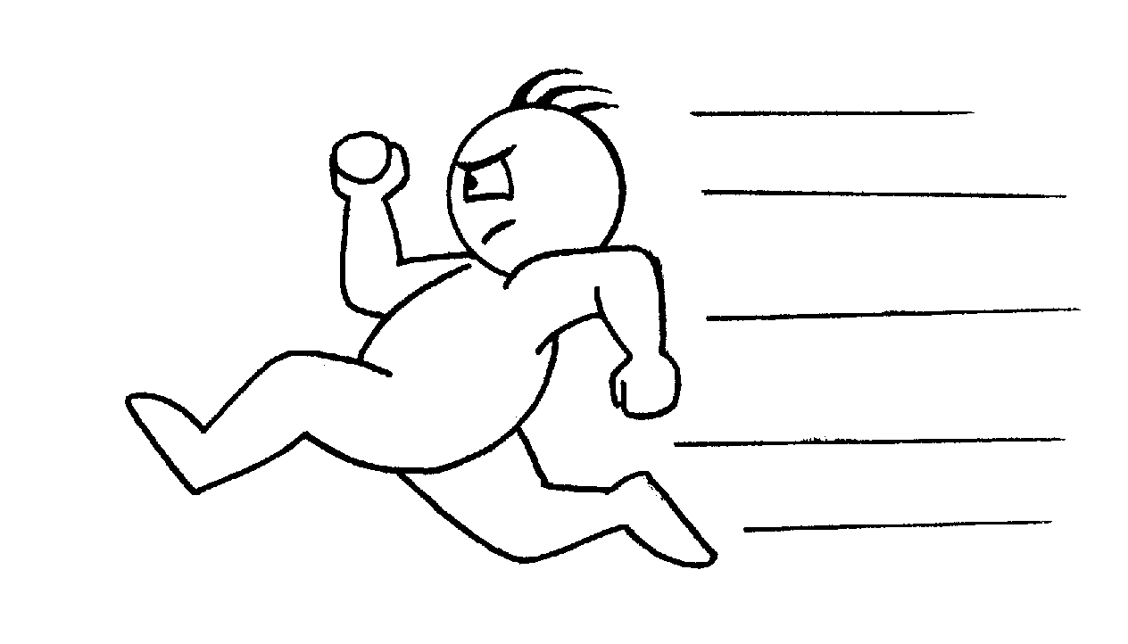

|  |  |  |  |
| --- | --- | --- | --- |
|  | **Lesson 1** | **Lesson 2** | **Lesson 3** |
| **Monday -** | **1 2 3 4 5** | **1 2 3 4 5** | **1 2 3 4 5** |
|  |  |  |  |
| **Tuesday-** | **1 2 3 4 5** | **1 2 3 4 5** | **1 2 3 4 5** |
|  |  |  |  |
| **Wednesday -** | **1 2 3 4 5** | **1 2 3 4 5** | **1 2 3 4 5** |
|  |  |  |  |
| **Thursday -** | **1 2 3 4 5** | **1 2 3 4 5** | **1 2 3 4 5** |
|  |  |  |  |
| **Friday -** | **1 2 3 4 5** | **1 2 3 4 5** | **1 2 3 4 5** |
|  |  |  |  |

**Total Score for the week:**

|  |  |  |
| --- | --- | --- |
| **About** X  **The 5P Approach Individual Green Zone**  *(General Information not in the 5P Profile and relevant to meeting x’s needs)* | | **NAME:** |
| **Communication** | X  *(What X needs to communicate to others)* |  |
| The adults  *(How adults communicate with x)* |  |
| **Environment** ( resources)  *Visual, sensory, physical, social* | |  |
| **Approaches to teaching & learning**  *(strategies and specific programmes)* | |  |
| **Day to day behaviour strategies at Green** *( from profile & information about the pupil, from previous intervention hierarchies)* | | |
| Situation/ Behaviour  *e.g. hitting* | | Strategy |
| Situation/ Behaviour  *e.g. screaming* | | Strategy |